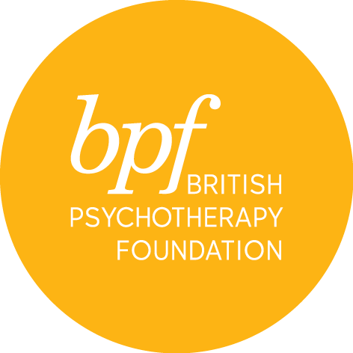

PPA reading group

Full Name:

Address:

Town:

Postcode:

Telephone:

Email:

Occupation:

Professional qualification:

Would you like to receive information about events and course at the bpf? YES/NO

I certify that the information contained in this application is true and complete. On signing this application form, I confirm that I have read and understood the cancellation and refund policies.

Signature:

Date:

Please return the completed form electronically to Sophina Khan, Training Manager at SophinaK@bpf-psychotherapy.org.uk

