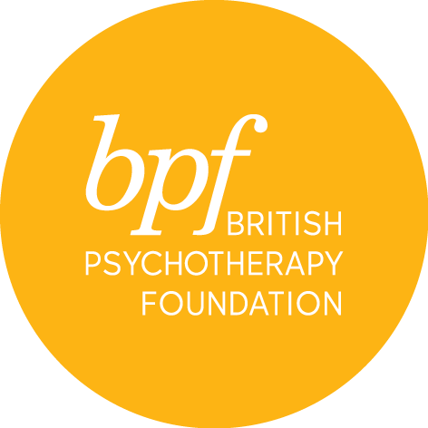

PPA reading group

Title:

First name:

Surname:

Address:

Town:

Postcode:

Telephone number:

Email address:

Please let us know which term you are signing up for – delete appropriately:

- Summer 2018: Thursday 6.30 - 8.00pm – 26 April; 3, 10, 17, 24 & 31 May; 7 & 14 June
- Autumn 2018: Thursday 6.30 - 8.00pm – 4, 11, 18 & 25 October; 1, 8, 15 & 22 November

Would you like to receive information about events and course at the bpf? YES/NO

On signing this application form, I confirm that I have read and understood the cancellation and refund policies.

Signature:

Date:

Please submit your completed application form electronically to the PPA Training Manager, sophinak@bpf-psychotherapy.org.uk. Please pay the fee using the payment link provided on the website.

