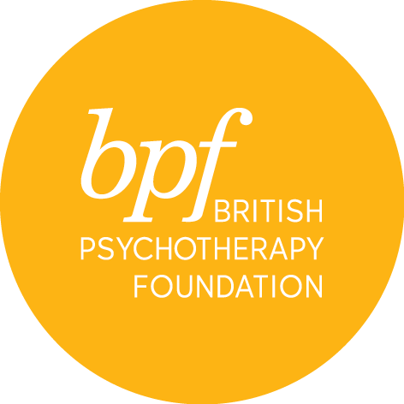
Foundation course
application

Full Name:

Address:

Town:

Postcode:

Telephone:

Email:

Tick all that apply below.

Which intake are you applying for:

October 2024 ☐

Have you already studied (or are currently studying) our Psychotherapy Today course?

Yes ☐

No ☐

Have you already studied (or are currently studying) our Psychodynamics of Human Development MSc course?

Yes ☐

No ☐

Which type of psychotherapist are you interested in becoming?*

Psychoanalytic psychotherapist ☐

Psychodynamic psychotherapist ☐

Jungian psychotherapist ☐

Child and adolescent psychotherapist ☐

I don’t know yet ☐

*We ask this so that we can offer you the right support during your studies, but you do not need to know for certain yet.

Which modules do you intend to study?

Both, I want to study the whole Foundation Course ☐

Just the clinical module ☐

Just the theory module ☐

Please give a brief description of your duties and responsibilities in your current role:

Please list your education history to date (and any qualifications you are currently studying for):

Please use this space to provide personal information in support of your application including reasons for applying for the course, reasons for wishing to study with us and any relevant practical experience, interests and achievements. This statement must be your own work (Word Limit 300-500).

Where did you hear about the course?

Where have you seen our ads? Tick all that apply.

findamasters.com ☐
Therapy Today (BACP Magazine) ☐
New Psychotherapist (UKCP Magazine) ☐
New Associations (BPC Magazine) ☐
Opera Magazine ☐
The Psychologist (BPS) ☐
Facebook Ad ☐
Instagram Ad ☐
LinkedIn Ad ☐
Google Search Ad ☐
I have not seen your ads ☐

equal opportunities

Completion of this section is helpful to ensure that we are aware of the communities applying for this scheme and assists in the implementation of equal opportunities. This information will not form any part of the selection process.

(Please tick the appropriate boxes)

a. Your Ethnic Group

Asian or Asian British |  | Mixed
Indian |  | White and Black Caribbean
Pakistani |  | White and Black African
Bangladeshi |  | White and Asian
Any other Asian background |  | Any other mixed background

Black or Black British |  | White
Caribbean |  | British
African |  | Irish
Any other Black background |  | Any other White background
Chinese |  | Any other ethnic group

b. Your Gender

Female |  | Male |  | Transgender |  | Prefer not to say

c. Sexual Orientation

Bisexual |  | Gay man |  | Heterosexual |  | Lesbian/Gay woman |  | Other

d. Your Disability

The Disability Discrimination Act (1995) defines a person as disabled if “they have a physical or mental impairment which has a substantial and long-term (has lasted, or is expected to last, for at least 12-months) adverse effect on their ability to carry out normal day to day activities”.

From this description, do you consider yourself to be a disabled person?

YES |  | NO |  | Prefer not to say

If yes, please advise what your condition is:

In terms of the Act we will take steps to make reasonable adjustments within the workplace to avoid those who have a disability from suffering a disadvantage.

e. Your Age – please tick appropriate box below:

18-25 |  | 26-35 |  | 36-45 |  | 46-60 |  | 60+

I certify that the information contained in this application is true and complete. On signing this application form, I confirm that I have read and understood the cancellation and refund policies.

Signature:

Date:

Please return the completed form electronically to Urvashi Chand, Foundation Course Director, at: foundation@bpf-psychotherapy.org.uk

