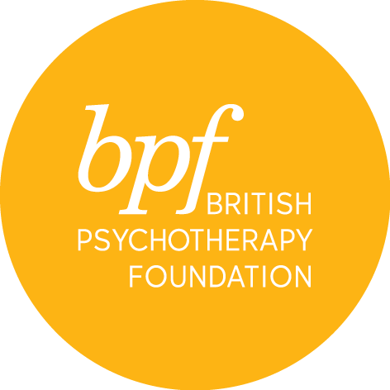

infant observation

Please note that:

- Parents of infants 0-12 months old are not able to commence their observations until their child has turned 1 year old.

- If an observation family has not been found after three terms, the student may be asked to leave the course.

Please note that for the duration of the course you are required to be in a minimum of once weekly psychoanalytic or Jungian Analytic psychotherapy

Full Name:

Address:

Town:

Postcode:

Telephone:

Email:

Marital Status:

Are you a parent? YES/NO

Professional qualification

Details of present employment & employer

Are you, or have you been in individual or group psychotherapy?

If so, please give details of length, frequency and discipline/orientation, name of organisation or therapist

Name and email address of two professional referees

Please write a statement outlining your interest and reasons for applying for this course in 200 - 300 words and attach a copy of your CV on submission

Are you applying to train with bpf?
Please specify if you are applying for a bpf training and if so, which (PPA,BJAA, or IPCAPA). Please also let us know where you are in the application process.

Would you like to receive information about events and courses at the bpf? YES/NO

I certify that the information contained in this application is true and complete. On signing this application form, I confirm that I have read and understood the cancellation and refund policies and to arrange payment of the admin fee on submission.

Where did you hear about the course?

Where have you seen our ads? Tick all that apply.

findamasters.com ☐
Therapy Today (BACP Magazine) ☐
New Psychotherapist (UKCP Magazine) ☐
New Associations (BPC Magazine) ☐
Opera Magazine ☐
The Psychologist (BPS) ☐
Facebook Ad ☐
Instagram Ad ☐
LinkedIn Ad ☐
Google Search Ad ☐
I have not seen your ads ☐

equal opportunities

Completion of this section is helpful to ensure that we are aware of the communities applying for this scheme and assists in the implementation of equal opportunities. This information will not form any part of the selection process.

(Please tick the appropriate boxes)

a. Your Ethnic Group

Asian or Asian British |  | Mixed
Indian |  | White and Black Caribbean
Pakistani |  | White and Black African
Bangladeshi |  | White and Asian
Any other Asian background |  | Any other mixed background

Black or Black British |  | White
Caribbean |  | British
African |  | Irish
Any other Black background |  | Any other White background
Chinese |  | Any other ethnic group

b. Your Gender

Female |  | Male |  | Transgender |  | Prefer not to say

c. Sexual Orientation

Bisexual |  | Gay man |  | Heterosexual |  | Lesbian/Gay woman |  | Other

d. Your Disability

The Disability Discrimination Act (1995) defines a person as disabled if “they have a physical or mental impairment which has a substantial and long-term (has lasted, or is expected to last, for at least 12-months) adverse effect on their ability to carry out normal day to day activities”.

From this description, do you consider yourself to be a disabled person?

YES |  | NO |  | Prefer not to say

If yes, please advise what your condition is:

In terms of the Act we will take steps to make reasonable adjustments within the workplace to avoid those who have a disability from suffering a disadvantage.

e. Your Age – please tick appropriate box below:

18-25 |  | 26-35 |  | 36-45 |  | 46-60 |  | 60+

Signature:

Date:

Please return the completed form electronically to Sandra Pereira, MSc, Post Graduate & Public Courses Officer at SandraP@bpf-psychotherapy.org.uk

