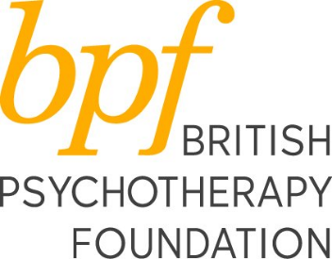

3 Senior Tutors - ACP registered Child and Adolescent Psychoanalytic Psychotherapists
Hours of work: 19 hours per week (must include Tuesday – training day)
Location: Combination of bpf’s offices at 37 Mapesbury Road, Kilburn, London NW2 and home-working
Salary: £32,000 - £36,000 per annum (0.5 FTE) commensurate with experience, (FTE £64,000 - £72,000)
The Independent Training, delivered in collaboration with IPCAPA at the British Psychotherapy Foundation (bpf) and the Anna Freud Centre/UCL is seeking 3 Senior Tutors to work on the Doctorate in Child and Adolescent Psychotherapy training.
This is an exciting opportunity to shape the delivery of Child Psychotherapy training to meet the challenging demands of working in the NHS.
We are looking for ACP registered Child and Adolescent Psychoanalytic Psychotherapists with 2 years post qualification experience and current CAMHS experience, who have an aptitude for teaching and supervising and an active interest in supporting trainees’ progress as a personal tutor.
The successful candidates will be ACP registered and will have:
- Experience working in the NHS
- An active interest in supporting trainees’ progress through providing high-quality teaching and supervision
- An ability to integrate clinical, research and academic learning and to actively participate in teaching, supervision and program delivery.
The bpf are committed to supporting and promoting equity and diversity and to creating an inclusive working environment. We believe having a diverse workforce at all levels allows us to attract and support students and patients from a range of backgrounds, and therefore welcome applicants from all communities. We would particularly welcome applications from black and minority ethnic and disabled candidates who are currently under-represented at the bpf.
For more information about the role and to apply, please contact:
Elizabeth Murphy (ElizabethMurphy@bpf-psychotherapy.org.uk), Clinical Director
Leah Mair (LeahMair@bpf-psychotherapy.org.uk), Training Manager
Your application should include your CV and supporting statement.
Closing date: 9am Monday 30th May 2022
Date of Interview: Monday 6th June 2022

