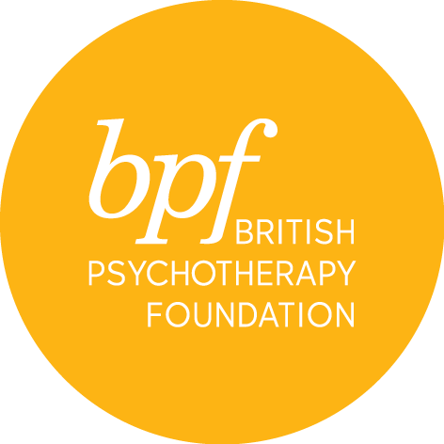

PPA reading group

Full Name:

Address:

Postcode:

Telephone:

Email:

Occupation:

Professional qualification(s):

- Please let us know which term you are signing up for – delete appropriately:

- Spring term
- Summer term
- Autumn term

- Please write a paragraph of not more than about 300 words about your past experience of psychoanalysis in any form, your reasons for applying for this course and anything else you think would be helpful for us to know. If you would like to talk to the seminar leader about this, or anything else related to the course please email alicecowley18@hotmail.com.

- Please tell us how you heard about the bpf and this course.

I certify that the information contained in this application is true and complete. On signing this application form, I confirm that I have read and understood the cancellation and refund policies.

Signature:

Date:

Please return the completed form electronically to Lydia Hortyn, PPA Training Coordinator, PPATraining@bpf-psychotherapy.org.uk

