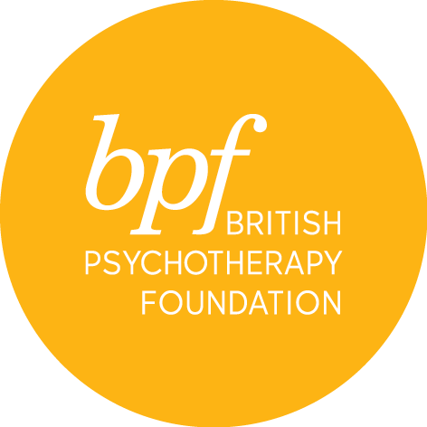

jungian dream workshops

Full Name:

Address:

Town:

Postcode:

Telephone:

Email:

Occupation:

Professional qualification:

Please give details of the discipline/orientation of your practice and/or any other relevant experience you may have.

Are you, or have you been in individual or group psychotherapy?
If so, please give details of length, frequency and discipline/orientation

What do you hope for from the course?

Where did you hear about the course?

Would you like to receive information about events and course at the bpf? YES/NO

Payment via debit card only will be due on acceptance of a place.

I certify that the information contained in this application is true and complete. On signing this application form, I confirm that I have read and understood the cancellation and refund policies.

Signature:

Date:

Please return the completed form electronically to Sandra Pereira, MSc, Post Graduate & Public Courses Officer at SandraP@bpf-psychotherapy.org.uk

