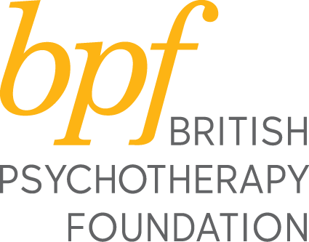

DEVELOPING SUPERVISION SKILLS 2022 – Ref CPD/16

APPLICATION FORM

NAME: ……………………….. TITLE:…………………………………..

ADDRESS:……………………………………………………………………………………

…………………………………………………………………………………………………
Home Tel.………………………………. Work Tel.………………………………………………..

E-Mail address:

PROFESSION:

PROFESSIONAL QUALIFICATIONS (degrees, diplomas):

DETAILS OF PSYCHOTHERAPY/COUNSELLING TRAININGS:

Training Organisation following
Qualifications : ……………………………………

Name of Training Organisation :……………………………………

Date of Qualification : ……………………………………

EMPLOYER:

PLEASE GIVE DATES AND ORIENTATION OF PERSONAL ANALYSIS/PSYCHOTHERAPY:

PLEASE GIVE DATES AND ORIENTATION OF PERSONAL SUPERVISION:

PAST EXPERIENCE OF BEING A SUPERVISOR :

CURRENT EXPERIENCE OF BEING A SUPERVISOR :

SETTINGS IN WHICH SUPERVISION TAKES PLACE :

PLEASE STATE YOUR AIMS IN ATTENDING THESE WORKSHOPS:

HOW DID YOU HEAR ABOUT THESE WORKSHOPS?

Tick here if you would prefer not to receive information about the bpf □

SIGNATURE:___________ DATE: _________

Course Fee
£850

Cancellation
All cancellations must be made in writing and subject to an admin fee of £25
100% refund will be given for cancellations up to 60 days before the course start date.
50% refund will be given for cancellations up to 30 days before the course start date.
No refund for cancellations received in less than 30 days before the course start date.

Please return this completed application form by email to :
Sandra Pereira, MSc, Postgraduate & Public Events Officer, British Psychotherapy Foundation, sandrap@bpf-psychotherapy.org.uk

