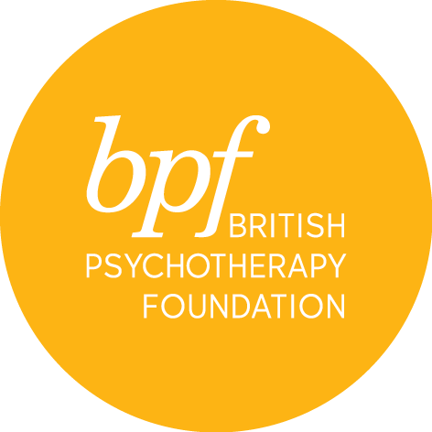

Jung reading group

Full Name:

Address:

Town:

Postcode:

Telephone:

Email:

Qualification:

Occupation:

Where did you hear about the course?

What is your interest in joining the Jung Reading Group?

I certify that the information contained in this application is true and complete. On signing this application form, I confirm that I have read and understood the cancellation and refund policies.

Signature:

Date:

Please return the completed form electronically to Sandra Pereira, MSc, Post Graduate & Public Courses Officer at SandraP@bpf-psychotherapy.org.uk

