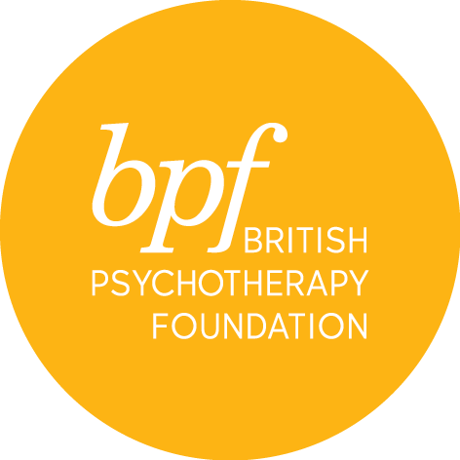

infant observation

Please note that:

- Parents of infants 0-12 months old are not able to commence their observations until their child has turned 1 year old.

- If an observation family has not been found after three terms, the student may be asked to leave the course.

Full Name:

Address:

Town:

Postcode:

Telephone:

Email:

Marital Status:

Are you a parent? YES/NO

Professional qualification

Details of present employment & employer

Are you, or have you been in individual or group psychotherapy?
If so, please give details of length, frequency and discipline/orientation, name of organisation or therapist

Name and email address of two professional referees

Please write a statement outlining your interest and reasons for applying for this course in 200 - 300 words and attach a copy of your CV on submission

Where did you hear about the course?

Would you like to receive information about events and course at the bpf? YES/NO

I certify that the information contained in this application is true and complete. On signing this application form, I confirm that I have read and understood the cancellation and refund policies and to arrange payment of the admin fee on submission.

Signature:

Date:

Please return the completed form electronically to Sandra Pereira, MSc, Post Graduate & Public Courses Officer at SandraP@bpf-psychotherapy.org.uk

