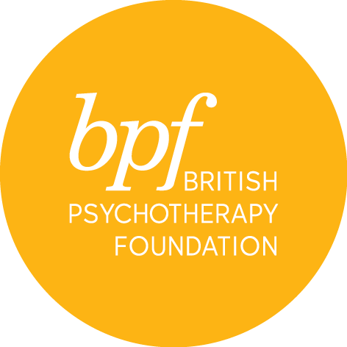

infant observation

Please note that:

- Parents of infants 0-12 months old are not able to commence their observations until their child has turned 1 year old.

- If an observation family has not been found after three terms, the student may be asked to leave the course.

Full Name:

Address:

Town:

Postcode:

Telephone:

Email:

Marital Status:

Are you a parent? YES/NO

Professional qualification

Details of present employment & employer

Are you, or have you been in individual or group psychotherapy?
If so, please give details of length, frequency and discipline/orientation, name of organisation or therapist

Name and email address of two professional referees

Please write a statement outlining your interest and reasons for applying for this course in 200 - 300 words and attach a copy of your CV on submission

Where did you hear about the course?

Are you applying to train with bpf?
Please specify if you are applying for a bpf training and if so, which (PPA,BJAA, or IPCAPA). Please also let us know where you are in the application process.

Would you like to receive information about events and course at the bpf? YES/NO

I certify that the information contained in this application is true and complete. On signing this application form, I confirm that I have read and understood the cancellation and refund policies and to arrange payment of the admin fee on submission.

Signature:

Date:

Please return the completed form electronically to Sandra Pereira, MSc, Post Graduate & Public Courses Officer at SandraP@bpf-psychotherapy.org.uk

